Enter Virtual environment as per the previous instructions, and pip install the requirements.txt file.

SPACY English language package:

Run the following command (This must be done as an administrator to correctly link):

python -m spacy download en

NLTK library installation:

Enter python shell and import the nltk library. Run nltk.download().

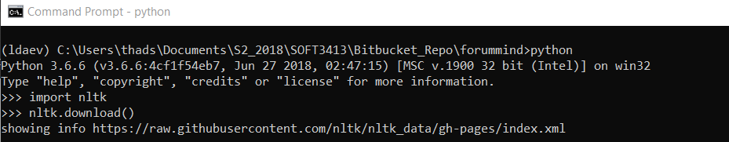

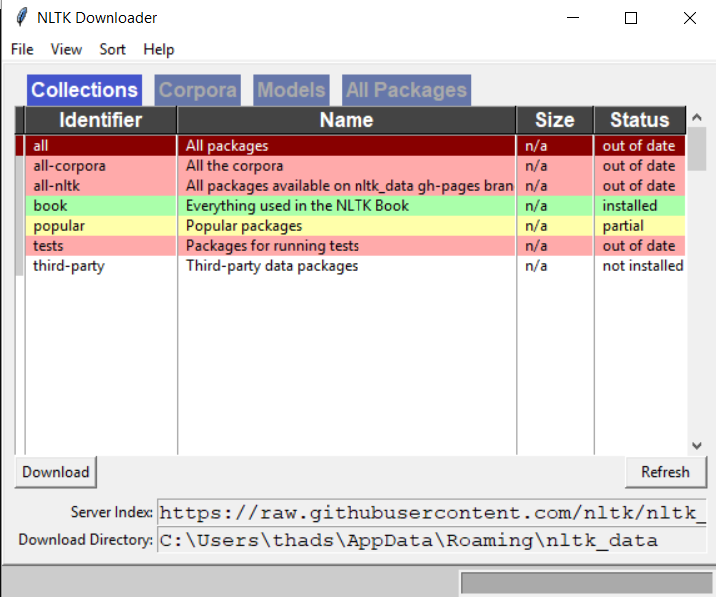This will open a gui window.

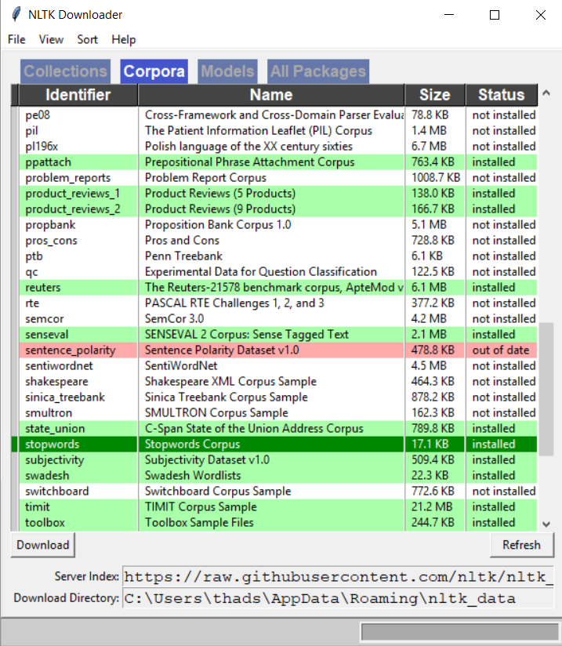Navigate to the corpora category and scroll down to find the stopwords category. Download this library.